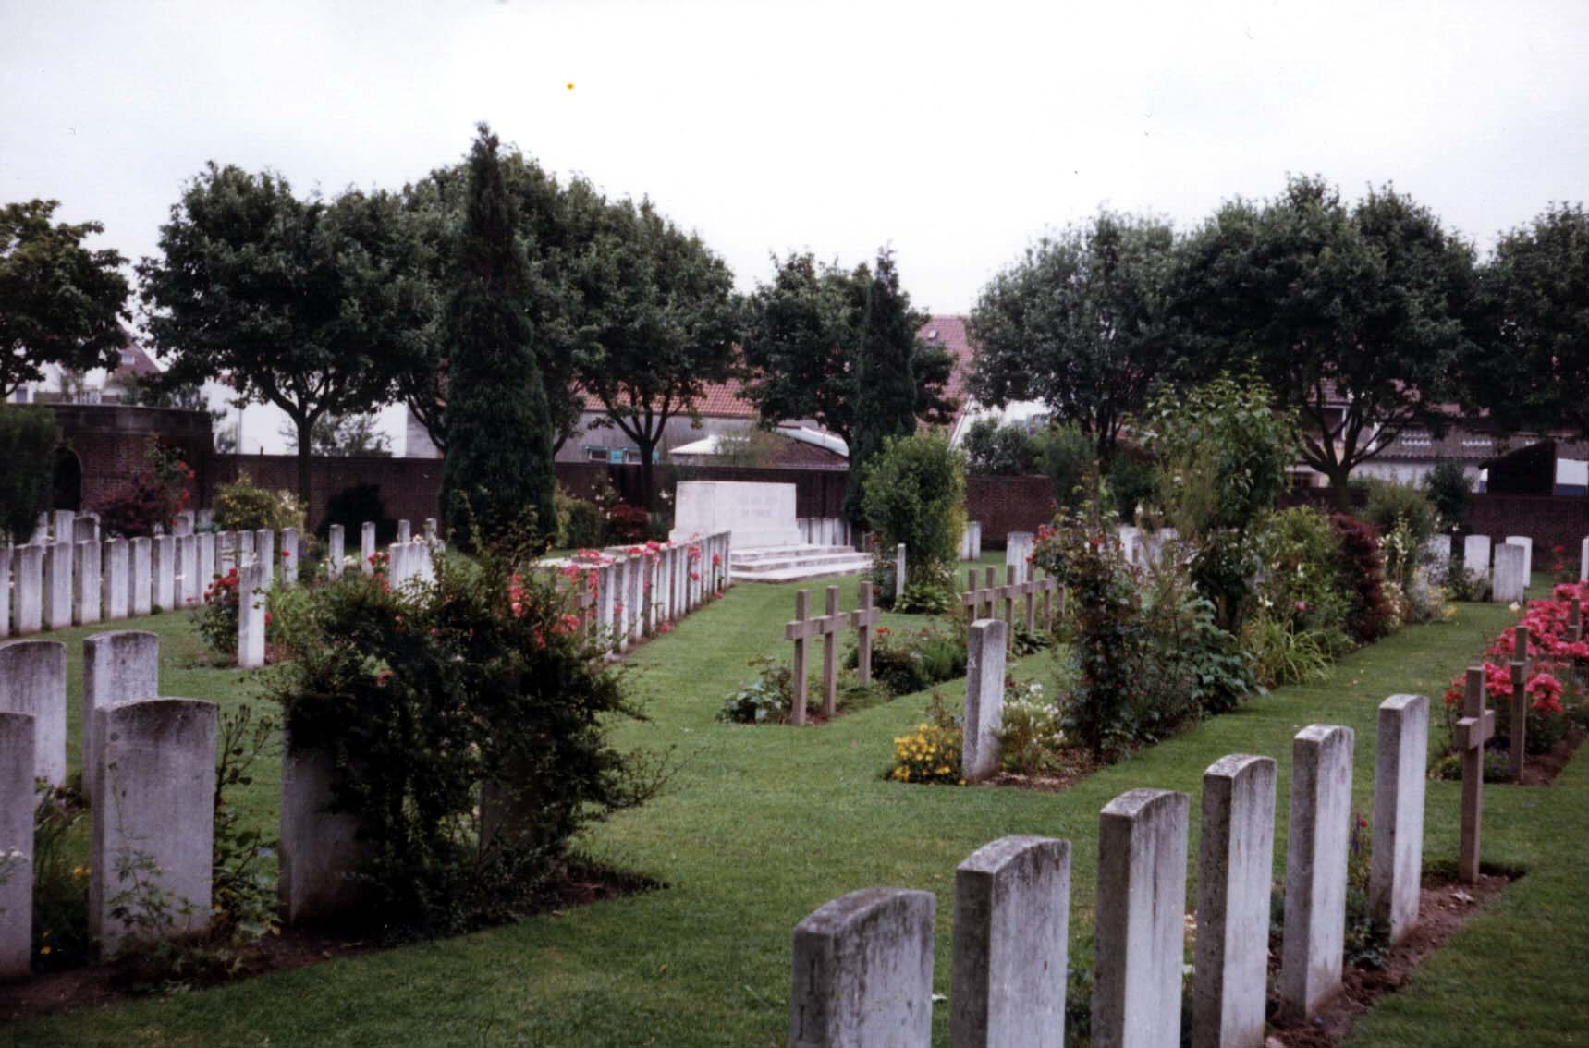
In Memory of
Private MONTAGUE WILLIAM DIXEY
11218, 5th Bn., Royal Berkshire Regiment
Born in Bampton, resided in Littleworth,
and died, age 40, on 2 June 1916
Remembered with honour
Faringdon War Memorial and
ST. PATRICK'S CEMETERY, LOOS

Commemorated in perpetuity by the Commonwealth War Graves Commission
The village of Loos-en-Gohelle is just north of Lens, Pas de Calais. St. Patrick's Cemetery was begun during the battle by French and British troops, and used in 1916 very largely by the units of the 16th (Irish) Division. It was closed in June, 1918, but a small number of graves were brought into it after the Armistice from the battlefields between Loos and Hulluch. The irregular arrangement of the rows is due to the conditions under which the burials were carried out. There are now nearly 600, 1914-18 war casualties commemorated in this cemetery. Of these, over 40 are unidentified and the graves of 23, destroyed by shell fire, are now represented by special memorials. The cemetery covers an area of 3,001 square metres and is enclosed by a brick wall.
From a letter to his mother published in the Faringdon Advertiser, it appears that William was shot through the head at night whilst constructing a Sniper Post that he was to occupy the following day. He was apparently an "excellent sniper". According to local rumour William was an employee of Major West of Barcot Manor. Major West offered his employees a sweetener of a gold sovereign and a new suit if they would enlist in the armed services. He enlisted at the beginning of the war and was sent to France in May 1915, arriving on June 1st.
Friday 2nd June 1916 France, Loos Sector: Battn was relieved by 7th Royal Irish Rifles and marched back into billets at Mazingarbe. Casualties: killed 3 other ranks; wounded 10 other ranks.
The following letter has been received by his mother, from his Captain:
Dear Madam,
I expect you will have received word from the War Office of the death of Private Dixey, and I would like to send you a few words of sympathy in your loss, and to tell you what a high opinion I had of him
He was always so keen and hard-working and thoroughly to be relied on to do what he was told to the best of his ability. He was a very keen sniper and he was shot through the head at night while working to make a place in the trench from which he could shoot by day without being seen.
Not long ago the officer who was training all the snipers of the battalion told me that Private Dixey was a splendid lad, and quite the best of the men he was training.
I feel that I have lost one of the best men in my Company.
With my sincere sympathy,
Yours truly,
P.B. Wace, Captain, Officer Commanding A Company, 5th Royal Berkshire Regiment
Captain Percy Beckwith Wace was killed in action on 3rd July 1916. His name is listed on the Thiepval Memorial
Ann Preston

